



**First Quarter Newsletter Jan – March 2020**



Hello Southpoint Owners,

Happy New Year!

Here’s a picture of the first sunrise of 2020 at Southpoint. Absolutely Gorgeous!

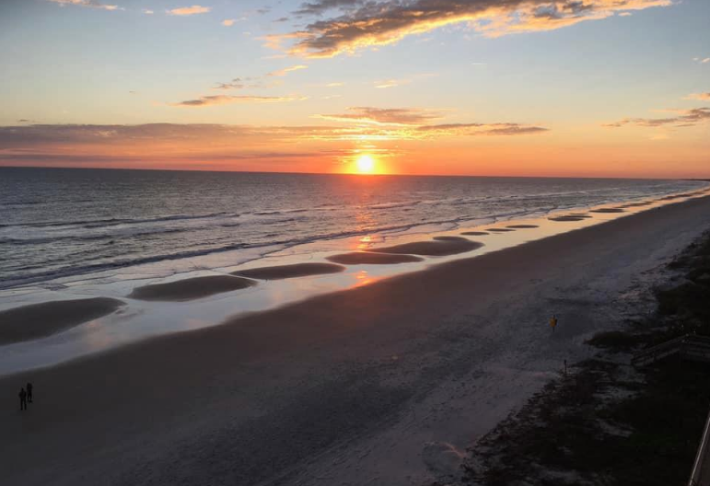

Photo credit goes to Darsa Pinholster.

The SPC Annual Meeting was held on December 7, 2019. As you can imagine, the hot topic on the agenda was the assessment for the window replacement and changing the bylaws. The current bylaws are the original ones and are in many respects, outdated and or in need of updates. Please review your copy of the SPC by-laws and then e-mail Kevin Bailey with any suggestions asap at [kevinbail@bellsouth.net](mailto:kevinbail@bellsouth.net)

Per Roger Koop, the following improvements have recently been made at Southpoint -

1. The pool furniture has been re-strapped.

2. Some exit lights blew off during a wind storm and Jeff has replaced those as needed.

3. Jeff is working in the generator room sanding and painting the rusted electrical panel covers.

4. Flowers were planted around the street sign however a strong wind storm burned them to the ground. It is difficult to find plants that will grow beach side.

5. The wheels on 2 luggage carts have been replaced with a tubeless urethane type as the original ones weren't durable.



Here are helpful tips and information, recommendations, and friendly reminders:

Remodeling? We as owners are responsible for making sure that all contractors sign in at the office. When they enter the building please be sure that they don’t leave the outside doors open. We need to keep the building secure. We are responsible for the contractors we hire make sure they adhere to the rules, clean up after themselves, and dispose of materials properly. If Jeff needs to clean up after a contractor, you will be billed for his time. Also, be sure that your contractor is not disposing your old flooring, carpeting, or any debris in our dumpsters, they need to remove it themselves. They should also be using their own carts, not our shopping carts or luggage racks. If doing your own renovating, please make sure that you make arrangements to have your old furnishings removed and disposed of properly and not placed in or around the SPC dumpsters. Paint is never allowed in the dumpsters and not allowed to be left outside of the dumpster area either.

Rubbish Disposal- There is a local dump in Volusia County, Tomoka Landfill, that we are allowed to use. You can dispose of used paint, furniture, and all types of trash there and it’s very inexpensive. There is also an area there that you can bring your good paint and take what others have left as well.

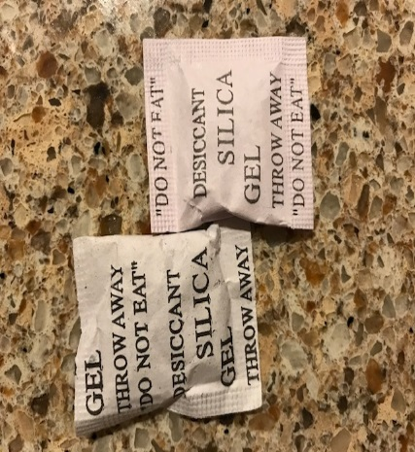

Do you typically toss these little packets? Well hang on to them as they are very useful in your condo where humidity levels can be high. These little white bags contain silica gel, the main use of which is to absorb moisture in the containers of shoes, clothing and tools, and also to get rid of bad odors.  
It is a poisonous substance where it should be kept away from children and pets, but nevertheless, it should not be thrown into the garbage because it has a lot of useful uses at home. Toss them in the way back of your utensil drawers, tuck a few behind the washer and dryer, the hot water tank area, under the sinks, in your tool boxes, owners closets, in the back of dresser drawers, etc. to keep items dry and prevent rusting. Other household uses are: put them in your jewelry boxes, toss a few in where you store old photos and important papers (such as birth and marriage certificates, real estate deeds), books, when storing shoes and handbags tuck them inside the items, luggage, linen closets, gym and sport bags. ***Note:*** Silica bags have a specific life and then stop working, after collecting and absorbing a lot of moisture, however they come in so many items we buy that they are easily replaced!

Toilets – Please remember to check your water supply lines to your toilets, sinks, dishwasher and washer. You should also test your water supply shut off valves a few times annually to be sure they are working properly. Replacing the toilet flappers inside the tanks annually is recommended. The flappers only cost $5-6.00 and the supply lines cost about $10-12.00. When properly maintained, these low cost replacements will reduce water usage and stop “running” toilets and leaks.

Hot Water Tanks – At the bottom of the tank is a water valve. It’s recommended that you use a garden hose, attach it to the threaded valve, open this valve up and drain a couple of gallons of water into a bucket to remove excess sediment in the tank. Plumbers recommend this should be done a few times a year.

Building Storage Closets- every floor has a locked storage closet located near the elevators that we as owners can use to properly store some items that you might not have room for in your unit. Whatever you decide to keep in the storage closet must be labeled with your unit # on it. We are not allowed to store any flammable items in there. Please be sure that your items are properly and neatly stored, keep an open path from front to back, and do not block any electrical or cable panels. These storage closets are shared by eleven owners so please be kind and share the space!



Owner Kevin Bailey has created an e-mail list with owner names, unit #, e-mail, telephone number and rental agency if you rent. If you’d like to be added to this owner listing, please contact Kevin with your information at [kevinbail@bellsouth.net](mailto:kevinbail@bellsouth.net) and he’ll add you.

Thanks, Kevin!



Let’s meet the Southpoint owners!

If you would like to be in the Owner Spotlight, send your story and some information and a picture or two to Linda Collette at [redcar@charter.net](mailto:redcar@charter.net)

There was lots of excitement in Ponce Inlet early in February with the North Turn parade and it’s festivities.

Do you recognize this guy? Richard Petty is a racing legend and he was right here in Ponce Inlet.





Another turtle was released by the Marine Science Museum too. This guy was released back to the sea on 2/11.

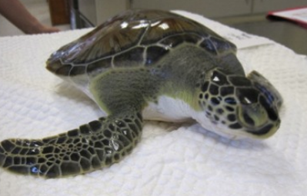

Facebook is a great social media tool to get us more exposure and it’s FREE. We have about 250 “Likes” and we can do better than that! Please invite your FB friends to “Like” our FB page.

Currently there are only 10 reviews on our FB page, only one more than last year. Please rate SPC on the FB page and leave a favorable comment. Doing this will help us all with more exposure and increased rentals.

**Your** Action Items:

1. Contact Kevin Bailey with your suggestions to the changes of our by-laws as soon as you can if you haven’t yet done so.

2. Please leave a favorable review on our Facebook page and encourage your friends and tenants to so too, as well as on Google and Trip Advisor.

3. Remember to “Like” both of the SPC Facebook pages, share the newsfeeds, interact with comments, stories, pictures, etc. The more interaction there is the more we’re seen on Facebook newsfeeds. Also, please take a minute and write a great review. Thank you!

If you have any newsworthy information you’d like to see here, pictures, etc., please share it with us. You may send any information to Linda Collette via e-mail to: [redcar@charter.net](mailto:redcar@charter.net), and please put “SPC Newsletter” in the subject line. Thank you!

**Southpoint Condominium Association Board of Directors:**

Phil Danley, President - [phil.danley@gmail.com](http://mailto:phil.danley@gmail.com/)

Alan Powell, Vice-President - [adp5721@comcast.net](http://mailto:adp5721@comcast.net/)  
Judy Voiers, Secretary/Treas.  [jvoiers@tampabay.rr.com](http://mailto:jvoiers@tampabay.rr.com/)

**Management Company: TJW Management Co, Inc.**

Roger Koop, Manager and Maintenance Supervisor, 386-788-4546 --[roger.koop@gmail.com](mailto:roger.koop@gmail.com) Karen Stewart - General Manager- kstewart@tjw.net